Adam optimizer is has given the best training results

Adam Optimizer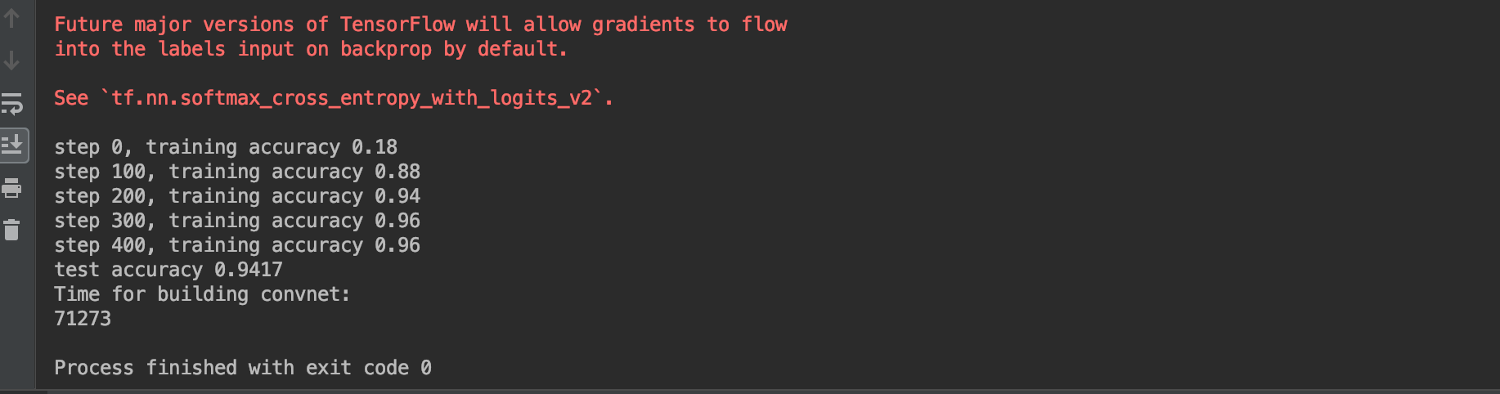

Gradientdescend

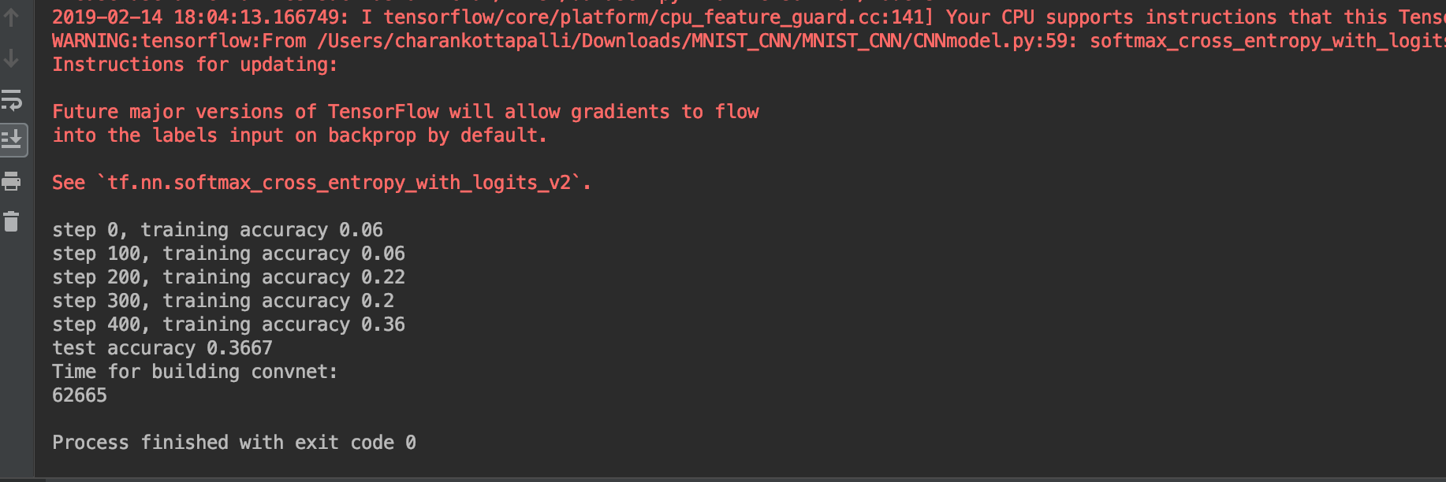

3. AdagradOptimizer

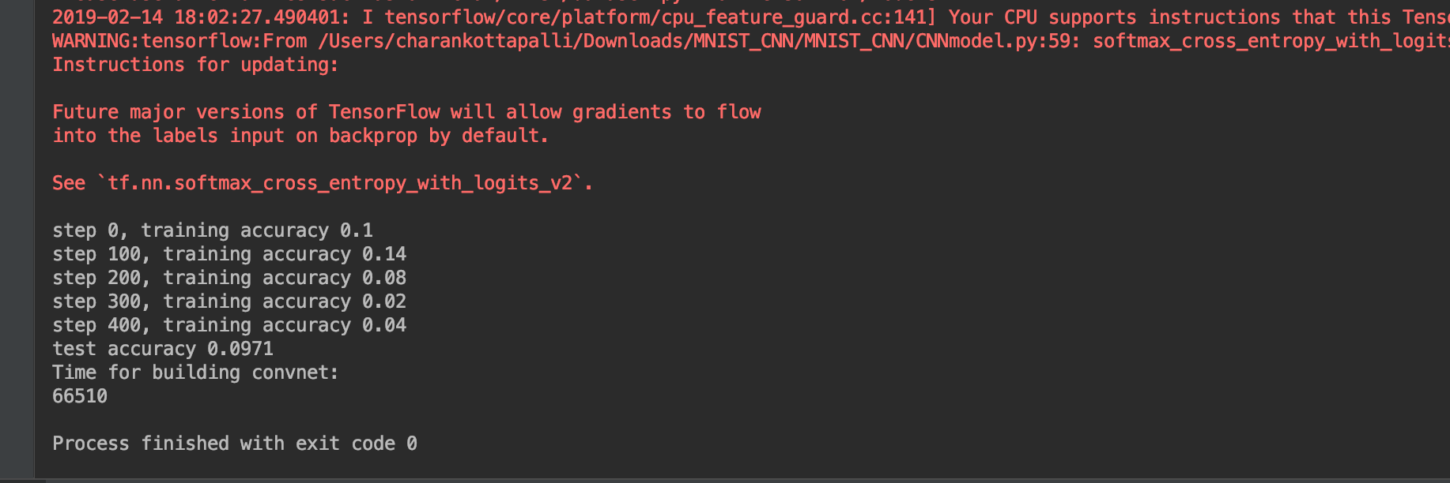

4. AdeltaOptimizer

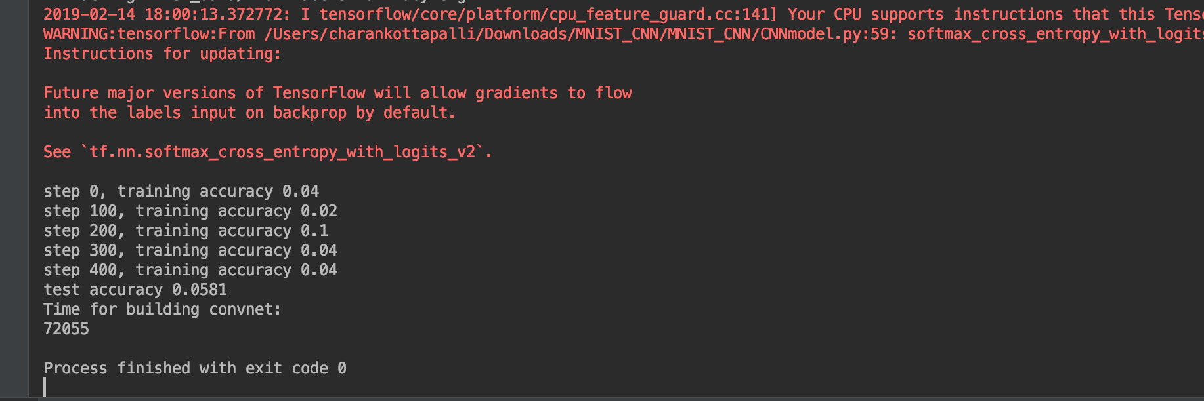

Playing with the Filters.

